Listening to Zeta
L. Stabile
February 2014

Introduction
While looking at plots of the Riemann zeta function and Riemann-Siegel Z function, I was inspired by the appearance to wonder what sound would be produced by the waveform implied by these plots. I found others had been similarly inspired, for example see Takusagawa [1]. Takusagawa calculated and produced an audio file for the Riemann-Siegel Z function, which requires considerable computational power and sophisticated algorithms. His work used large amounts of computer power to produce not only very long audio files but large scale tabulations of the zeta function and its zeroes.
In this work I chose a simpler approach; however the auditory properties bear many similarities to [1] and as shown the approach allows a somewhat deeper analysis of the perceptual properties of the sound.

Exposition
We start with the Euler form of the zeta function:
$$\text{ζ(s)=}\sum_{\text{n=1}}^{\text{∞}}{n^{-s}}$$
(1)
Note that this series preceded the zeta function as defined by Riemann, the latter being the analytic continuation of the Euler form to the entire complex plane other than for s = 1 (see [2] and [4]).
The Dirichlet series analytically continues (1) to the complex plane where Re(s) > 0 (see [4]). Its derivation begins by writing
$$\text{ζ(s)=2}\sum_{\text{k=1}}^{\text{∞}}{{\left(2k\right)}^{-s}-}\sum_{\text{n=1}}^{\text{∞}}{{{\left(-1\right)}^{n} n}^{-s}}$$
(2)
and winds up after elementary manipulation as
$$\text{ζ(s)=}\frac{1}{1-2^{1-s}}\sum_{\text{n=1}}^{\text{∞}}{{{\left(-1\right)}^{n} n}^{-s}}$$
(3)
(3) provides a computationally reasonable way to evaluate zeta on the critical line Re(s) = ½.
Letting s = x + iy, (2) becomes:
$$\text{ζ(}x\text{+}iy\text{)=2}\sum_{\text{k=1}}^{\text{∞}}{e^{\left(\ln\left(2k\right)\right)\left(-x\right)}e^{-i\left(\ln{ \left(2k\right)}\right) y}-}\sum_{\text{n=1}}^{\text{∞}}{{\left(-1\right)}^{n} e^{-(\ln{ x) y} }e^{-i(\ln{n) y}}}$$
(4)
and letting x = ½ we get:
$$\text{ζ(}\frac{1}{2}\text{ + }iy\text{)=}\sqrt{2}\sum_{\text{k=1}}^{\text{∞}}{{\frac{1}{k}e}^{-i\left(\ln{ \left(2k\right)}\right) y}-}\sum_{\text{n=1}}^{\text{∞}}{{\left(-1\right)}^{n}\frac{1}{\sqrt{n}}e^{-i(\ln{n) y}}}$$
(5)
The Fourier transform of (5) is easy to derive by inspection. From an auditory point of view, we can posit that the essence of the transform is characterized by a line spectrum of logarithmically related frequencies, with amplitudes that diminish as $\frac{1}{\sqrt{n}}$:
$$\text{F(ω)=}\sum_{\text{n=1}}^{\text{∞}}{\frac{1}{\sqrt{n}}δ(ω-\ln{n)}}$$
(6)
We can write a suitable discrete version of this transform by letting $ω= kω_{T}$, where the unit of frequency granularity $ω_{T}=\frac{ω_{S}}{N}$, where $ω_{S }$is the sampling frequency and N is the number of samples in the transform:
$$\text{F(}\text{k}\text{)=}\sum_{\text{n=1}}^{\text{N}}{\frac{1}{\sqrt{n}}u_{0}\left\lfloor \left.(kω_{T}-\ln{n)}\right\rceil \right.}$$
(7)
where the notation $\left\lfloor \left.x\right\rceil \right.$signifies round (x). This can be expressed as the sequence:
$$\text{F(}\text{k}\text{)=}\left\{\begin{aligned}\frac{1}{\sqrt{n}}, k=\left\lfloor \left.{\ln{n}}/{ω_{T}}\right\rceil \right., n=1…N \\ 0 for all other values of k\end{aligned}\right.$$
(8)
A linear-scale plot of (8) is shown below, with suitable scaling for graphic display purposes:
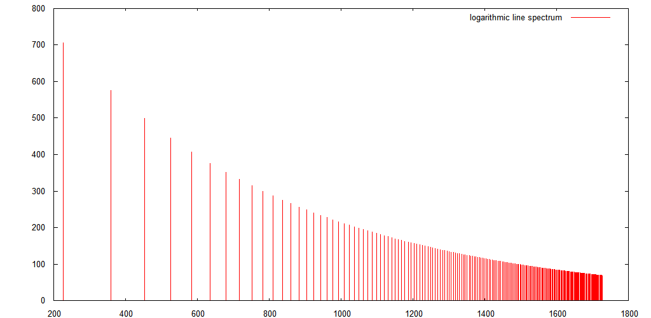
The sound file below was produced using equation (3), with time scaling suitable for bringing the function into audible range. 1000 terms of the series were evaluated, using a direct computation (i.e., not via inverse transforms or similar techniques). The sampling rate is 40kHz.
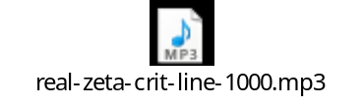
The next sound file is based on equation (6), which of course is directly analogous to equation (1). For efficiency an inverse FFT was used to produce it. Due to computational limitations it is shorter than the previous file. However 14,685 terms are represented here, in a 2²² (4,194,304) point DFT . Since the file was produced by inverse transform, it is symmetrical in time; thus you will hear it “building up” to a midpoint, then building back down.

The Euler series form of the zeta function (equation (1)) does not converge on the critical line. However if we are interested in the auditory effects then there is a frequency limit above which additional signal will not be audible.
Interestingly, this limit is only reached with a very large number of terms, if we start with a fundamental frequency in the comfortable musical mid-range, e.g., middle C or approximately 261.63 Hz. A basis frequency is established as follows:
$$ω=ω_{0}\ln{n}$$
Therefore for a given $ω_{max}$ :
$$n_{max}=e^{\frac{ω_{max}}{ω_{0}}}$$
$ω_{0}$ is established by using an initial value of n = 2, since ln 1 = 0. If we establish the initial frequency at roughly middle C, then a factor of 100 brings us above audible range. Therefore we can estimate that
$$n_{max}=e^{100}\sim 2.7x{10}^{43}$$
This is indeed a large number of terms. Of course, the amplitude diminishes by $\frac{1}{\sqrt{n}}$. 50 dB down occurs at n = 10⁵, and masking effects imply that many fewer terms are required to get a similar audio effect. To show this empirically, the following sound file is based on only 100 terms (also produced by inverse FFT, so the same length and symmetry comments as above apply):

However at 10 terms the sound becomes qualitatively different:

Note also that the $\frac{1}{\sqrt{n}}$ amplitude factor generally diminishes the harmonic amplitude much more slowly as a function of frequency than typical sounds we might hear in the environment, or in human speech, or music. In general sounds with high harmonic content are not pleasant and are annoying when they occur for more than short periods, for example jackhammers or very loud, close thunderclaps. As humans we try to minimize our exposure to and production of them. However this particular sound is not unpleasant, at least in the same manner as given by the examples. It could be called spooky or spaceship-like, and may sound disturbing to some.
When we listen to the variations on the zeta function, we are struck by both the similarities and differences among the variations. They sound similarly spooky, but different in the subtle changes in the beats and warbles over time. I hypothesize that these effects are due primarily to the logarithmic relationship between the frequencies of the harmonics, in particular the ever-decreasing ratio between the frequencies of adjacent harmonics as frequency increases. This ratio is $\frac{\ln{(n+1)}}{\ln{(n)}}$, and approaches unity as n approaches infinity. The figure below illustrates this ratio.
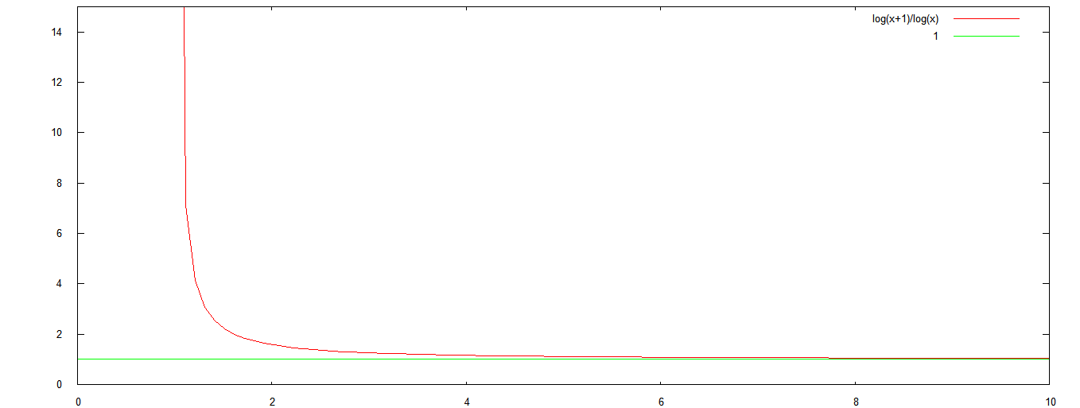
Adding terms changes the complexion of the zeta function audio in subtle ways. When listening to long recordings, the alteration of the timing of beats and the sweep of the warbling are noticeably different in recordings with differing numbers of terms. This is empirical evidence of the wide range of behaviors captured by the Riemann zeta function. Listening to some portion of this function is one way to appreciate the complexity. Of course, as with electromagnetic phenomena, of which we can only perceive a small part, the zeta function is infinitely vast, and we can only perceive that part of it which we can approximate using our limited-resolution tools and senses.
A related and fascinating aspect of the zeta function is universality. As shown by Voronin [3], the Riemann zeta function can approximate any function, including itself, by suitable shift along the critical strip. An exploration of the theoretical, practical, and aesthetic properties of this and related theorems should be worthy of pursuit.
Further exploration of the nature of the zeta audio should also prove interesting. For instance we might continue along the lines above and analyze more sounds with logarithmically related spectral components, with various levels of harmonic content.

References
- Ken Takusagawa, Tabulating values of the Riemann-Siegel Z function along the critical line, http://web.mit.edu/kenta/www/six/parallel/2-Final-Report.html
- Bernhard Riemann, On the Number of Prime Numbers less than a Given Quantity, November 1859, http://www.claymath.org/sites/default/files/ezeta.pdf.
- Steuding, Joern. "Voronin Universality Theorem." From MathWorld--A Wolfram Web Resource, created by Eric W. Weisstein. http://mathworld.wolfram.com/VoroninUniversalityTheorem.html
- Sondow, Jonathan and Weisstein, Eric W. "Riemann Zeta Function." From MathWorld--A Wolfram Web Resource. http://mathworld.wolfram.com/RiemannZetaFunction.html

Word does not have a good way to number equations, so please excuse this placement of the number on the subsequent text line.
Reasonable in the sense that it converges, though slowly, and does not involve the introduction of difficult to evaluate functions such as gamma.
“Computational limitations” simply means I’m using a relatively homely old PC and suboptimal software.
Inverse FFT is used in this case; its primary advantage is that its running time does not depend on the number of terms we wish to evaluate.
This is clear since $\frac{\ln{(n+1)}}{\ln{(n)}}=\frac{ln⁡\frac{⁡n∙(n+1)}{n}}{ln({n)}}=\frac{ln({n)}+ln⁡(1+\frac{1}{n})}{ln({n)}}=1+ \frac{ln⁡(1+ \frac{1}{n})}{ln({n)}}$

