Aunt Betty's Clock
Seth Thomas circa 1900
Model 89 movement
L. Stabile
January 12, 2018

Introduction
Aunt Betty’s clock was probably purchased soon after being manufactured, which we believe was around 1900. This clock’s complete history is unclear, but it’s most likely that Aunt Betty’s father kept it wound and running well. He died in 1950, and the clock sat on a mantle or shelf, stopped, from then until 2017, when we acquired the clock after Aunt Betty died.
The model 89 movement and variants thereon were used in many Seth Thomas clocks. Information about them abounds, and videos and so forth can be easily found on the net.
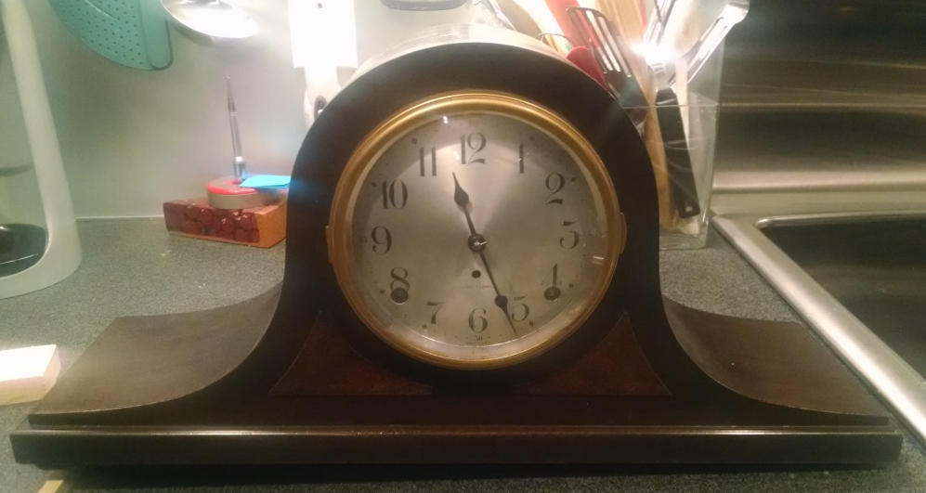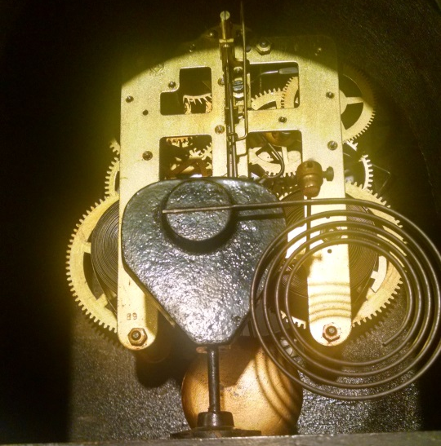
Figure 1 -- Aunt Betty's Clock

Mechanical Analysis
The escapement mechanism in a mechanical clock is a gear, coupled typically to a pendulum, such that the swinging motion of the pendulum causes the motion of the gear train to occur only in discrete, fixed-time steps. Thus time is quantized, in units corresponding to the pendulum’s natural period. In addition to creating this quantization, the escapement also gives the pendulum a push – the “impulse” – to keep it going.²
Since the gear train that drives the escapement also drives the hands, measurement of the hands is therefore a function of the time, and only deviations from linearity will cause the hands to show an inaccurate measure of the true time. While surely some nonlinearity exists, the main cause of inaccuracy is variation in the escapement period, which in turn is determined by a combination of the pendulum period and the force from the spring via the escapement gear.
Mechanically, the force of the spring is geared down and drives the escapement. The force driving the escapement needs to be large enough to keep the pendulum moving, but not so large as to materially affect its period. Note that cleanliness of the escapement gear and verge (the C-shaped piece attached to the pendulum shaft), and light lubrication of the bushings, is essential for the escapement and moving pendulum components, as these components move at a relatively high rate. This is not so important at earlier gear stages, due to their extremely slow motion. I.e., they move so slowly that friction due to bad lube and related factors is negligible.
Of significance is to determine the effect of the impulse force of the escapement on the pendulum. This has been well-analyzed and there are many types of escapements, each with its accuracy and stability properties.
Ideally, one wishes to impart only as much energy as is lost due to friction. However, adding more than this energy will keep the period constant, if this energy is fixed from swing to swing. This is not possible to assure with a spring-driven mechanism, however there are many designs that compensate in varying degrees for non-constant spring force.
One such design, as used in the 89 movement, is the deadbeat escapement, which means the recoil, or pushback from the lock phase, is minimized, by shaping the verge so that it interlocks smoothly with the escapement gear teeth. Nevertheless, there are unavoidable sources of error. The remainder of this paper will display an analysis of the accuracy and errors found in Aunt Betty’s clock.
If as above we assume the gear train and hands do not introduce nonlinearity, then the tick-tock period is a true measure of the time. It is a clock, after all. We will assume a time standard against which we measure as the "real" time, called t. Let the quantized real time be determined by nT_{r}, where n is the tick number and T_{r} is the tick-to-tick period. Thus,
$$t = nT_{r}$$
Suppose some error ϵ in the period is introduced. Then the absolute error ϵ_{a} is
$$ϵ_{a}=\left|nT_{r}-n\left(T_{r}+ϵ\right)\right| \\ =nϵ \\ =\left|\frac{t}{T_{r}}\right| ϵ$$
The relative error ϵ_{r} is simply
$$ϵ_{r}=\left|\frac{ϵ}{T_{r}}\right|$$
In this analysis, I made use of audio recordings of the ticks, using a cell phone recorder at 32 kHz sampling rate and 16 bit resolution (see further detail below). Using this method, in the 89 movement, the tick-to-tick period was measured at about 735 msec. Taking this figure as a nominal T_{r}, then over a day we have
$$n=\frac{3600∙24 sec}{735 msec}=117551 ticks$$
If ϵ is as little as 50 usec on average over the course of the day, then the time at the end of the day will be off by about 5 sec. So the ticks must be consistent to a fairly fine level to get accuracy over a reasonable interval.
The 89 movement needs to be wound weekly, and thus far I have observed its behavior over a few weeks. For a reference I'm using a WWVB-synced watch, which is accurate at least to the second, which is all that's really needed here. The speed of the clock is determined by the pendulum length, which in turn is controlled by a screw adjustment that moves a bar over a very flexible piece of metal which forms part of the pendulum shaft. It is quite sensitive and just a fraction of a turn can cause a significant speed change. Also, the clock needs to be level, so that the swing is symmetrical. It took much fine adjustment to get the period reasonably accurate.
To get a handle on the sensitivity, note that for small swing angles the period of a pendulum is given by
$$T=2π\sqrt{\frac{l}{g}}$$
where l is the pendulum length and g is the acceleration due to gravity. Thus
$$l=g{\left(\frac{T}{2π}\right)}^{2}$$
and
$$\frac{dl}{dT}=\frac{gT}{{2π}^{2}}$$
Using this last formula, we find that, at a nominal T_{r} of 735 msec, a period deviation of 50 usec is induced by a change in length of only 0.018 mm. Since 50 usec can alter the time by 5 sec per day, this illustrates the highly sensitive nature of this control.
Having adjusted the speed control to get reasonable accuracy, I then made informal observations over the course of a week, for three weeks in a row. The clock was wound each Saturday, and typically was accurate to within a few seconds until late Thursday, after which it slowed to where it was a minute or more off when Saturday came around again.

Signal Analysis
I made recordings of the ticking sound with a cellphone recorder app. Each recording was for about 5 minutes, at a sampling rate of 32 kHz and a resolution of 16 bits. Figure 2 shows a sample of such a recording. Note there is a “noise floor”, indicative of general background noise in the area.
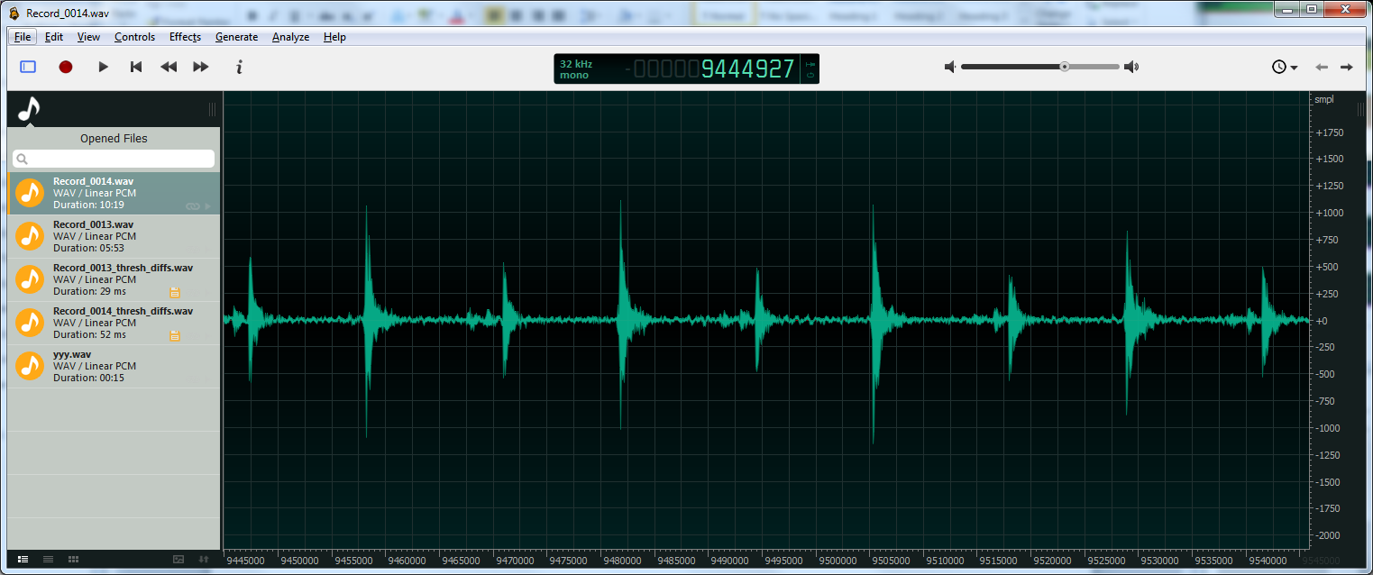
Figure 2-- Sample of a tick-tock audio recording

I then passed the signal through a thresholder filter, which spotted values above 300 or so (large enough to detect the peak of each tick and tock). The filter retained the first value seen of this size, and discarded (recorded as zero) the next 10000 samples (312.5 msec). This assured that we eliminate as many extra such peaks as possible. Values not passing these threshold tests are recorded as zero.
This produces a series of unit pulses, the delta-t between which is the tick-to-tock or tock-to-tick time (see Figure 3).
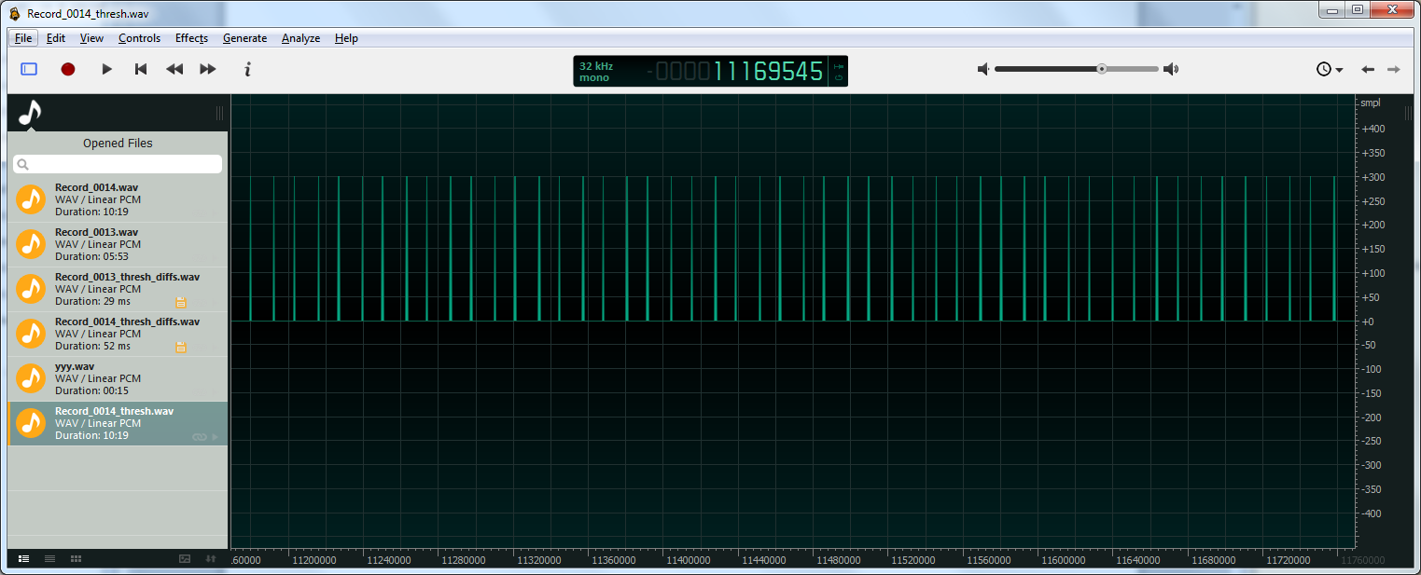
Figure 3-- Tick-tock audio after thresholding to produce tick-to-tock and tock-to-tick pulses.

A subsequent filter records the time (sample) difference between these pulses, resulting in a series of tick-to-tock and tock-to-tick differences. A further filter phase adds these values in pairs, so we have a series to tick-to-tick time differences; call these delta-ticks.
On plotting these using a wave editor, variation of the delta-ticks can be seen to span almost 5 msec. However I was surprised to see clear periodicity in this variation of the delta-ticks (Figure 4).
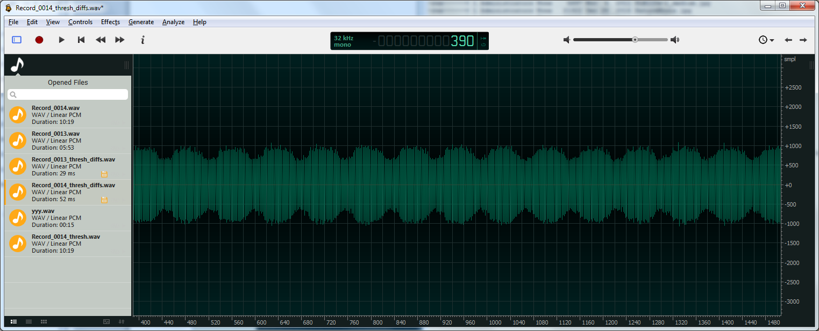
Figure 4 -- Delta-tick values (normalized to zero), showing the periodicity of the variation, conjectured due to non-uniform escapement gear teeth and/or axle bushing wear.
On closer inspection, the period came out consistently to 78 samples. This is accounted for by the fact that there are 39 gear teeth on the escapement. So it's plausible that variations in the teeth or axle bushings due to wear, manufacturing tolerances, and so forth account for the delta-t variation. However, since the escapement gear is circular, these variations are periodic and hence overall they are consistent. We thus have a delta-t per revolution which will vary predominantly by variations in the forces on the pendulum. The circularity of the escapement gear therefore compensates for wear and error due to manufacturing tolerances.
To quantify the weekly slowdown, I made two audio recordings, one on Saturday just after winding, and another almost a week later on Friday evening. The two recordings were processed as described above, to produce differential delta-tick files. The two files are plotted in Figure 5, and it is easy to see that the later recording has considerably larger delta-tick values. Averaging the delta-tick times of each file produced a delta-tick time of 736.17 msec on Saturday, and 737.83 msec on Friday, a difference of about 1.7 msec. Over the course of a day (117551 ticks), this amounts to a couple of minutes error.
I do not yet have a theory as to why the slowdown is non-linear.
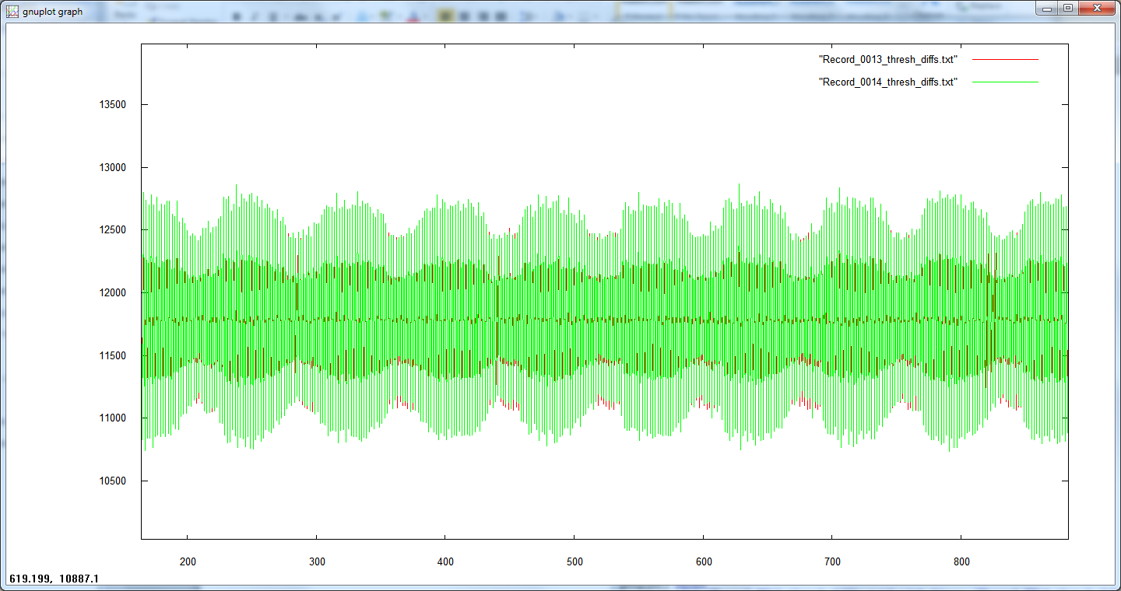
Figure 5 -- Difference in delta-ticks shown after a week of clock operation. The green is the later recording.

Conclusion
The analysis herein has produced some interesting results, but also raises questions and asks for more depth.
The escapement and pendulum assemblies are the main determinants of clock accuracy and consistent operation. The escapement teeth and verge must be very clean, and bushings well-formed and only very lightly lubricated. These parts move at a high enough speed that these attributes are the most important for clock operation. Bushings and gears earlier in the drive train move slowly enough, and have enough force behind them, that their lubrication and bushing quality are less of an issue. Very old clocks that have been running for decades can have issues in this manner, however, so this should not be overlooked. However if a clock is not working I recommend looking first at the escapement and related parts before disassembling the entire clock.
These clocks need to be level. Also, be careful if you transfer movements between cases, as the manufacturing of the day means that there may be variations in case dimensions and movement mounting point. The face and movement may therefore be rotated relative to its position in its original case, causing the mechanism not to be level, even when the case itself is level.
I don’t have a good explanation as to why the clock slows down in a non-linear manner. A conjecture is that the escapement design is good enough to compensate for changes in spring force, up to a point, after which it falls off. There may be more leveling issues to examine. However I have no quantitative explanation and this deserves more investigation.
I was generally surprised at the accuracy I could obtain from the clock. Considering its sensitivity to small changes in parameters, it is laudable that accuracy to a few seconds can be had over the course of several days.
An acoustic analysis of greater precision than performed here might also be of interest. The current signal acquisition techniques, though relatively coarse, allow millisecond variations to be easily observed. More refined recordings, using higher sample rates, finer resolution, better isolation from background noise, and from multiple points at once, could yield interesting insights into the mechanism itself.
The most surprising finding to me is the variation in tick-to-tick time, apparently due to escapement gear irregularities. And the invention itself would not work without circularity – it’s a mechanism that corrects errors in its own manufacture. I even made a song out of it:


I have not measured the gear-down, however we can estimate it as the ratio of one hour (the slowest gear rotation is at least this slow), to the time needed for one rotation of the escapement. This is 39 (number of teeth) times one-half a tick (735 msec / 2) ~= 14 sec. Thus the gear-down ratio is at least 250.
See https://en.wikipedia.org/wiki/Escapement for a good start on escapements, their operation, and history.
See https://www.youtube.com/watch?v=yZQM0CQqXQ0 for a video of an 89 escapement in action.
See https://en.wikipedia.org/wiki/Gravitational_acceleration. We use the 45-degree latitude constant for g: g = 9.806 meters per sec² = 32.17 ft/sec² = 386.04 in/sec².
The value of each entry is the time difference in number of samples. We get this difference in conventional units by multiplying by the sample period, 1/32000 = 31 usec.
C. Gandarillas, personal communication.

